|  |  |  |
| --- | --- | --- |
| Computer Networks (BSR-5A)  Quiz 01 (Fall 2023). Instructor: Dr. Syed M. Irteza | | Name: ***SOLUTION*** |
| Date: 2023-09-13 | | Roll Number: |
| Total Marks: 12 | Time Allowed: 12 mins |

1. FDM and TDM are methods to enable bandwidth to be shared among users of: (1m)
   1. ***Circuit-switched networks***
   2. Packet-switched networks
   3. Both virtual circuit-switched and packet-switched networks
   4. Neither virtual circuit-switched nor packet-switched networks
2. If we have a shared outgoing 40Mbps link to the Internet for our local area network (LAN), and we assume each user needs 400Kbps when active, how many users can we manage if we want to enable circuit-switching? (1m)
   1. 50
   2. 10
   3. ***100***
   4. 1
3. If each packet is 20Mb (Megabits), and the transmission rate of each of our links is 1Mbps (Megabits per second). Assume that we have two end hosts, E1 and E2, connected to each other by way of 2 links (a link is indicated by --------- ) with a switch in between, like this: (2m)

E1 --------- (switch) --------- E2

What is the expected delay for our packet-switched network for 1 packet sent from E1 to E2?

* 1. 10 seconds
  2. 20 seconds
  3. 30 seconds
  4. ***40 seconds***

1. Store-and-forward makes sure that: (1m)
   1. All packets are sent using circuit-switching
   2. ***All bits within a packet must first be received at a switch/router, before being forwarded to the next link***
   3. All packets within a file must first be received at a switch/router, before being forwarded to the next link
   4. All packets are sent using FDM
2. If congestion in a network increases, we would expect propagation delay to increase? Would you agree with this statement? (2m)

***No. Propagation delay should not be affected by traffic congestion within the network. This is related to the material of the physical network links. Such congestion should affect the queuing delay.***

1. What is the end-to-end packet latency (delay) in this store-and-forward network from router 1 to 6? You may assume the following: (5m)
   1. All links are 2.5 km, Link capacity = 100 Mbps, Propagation speed = 200m/microsec
   2. Queueing delay = 0, Processing delay = 0, packet size = 1000 bytes

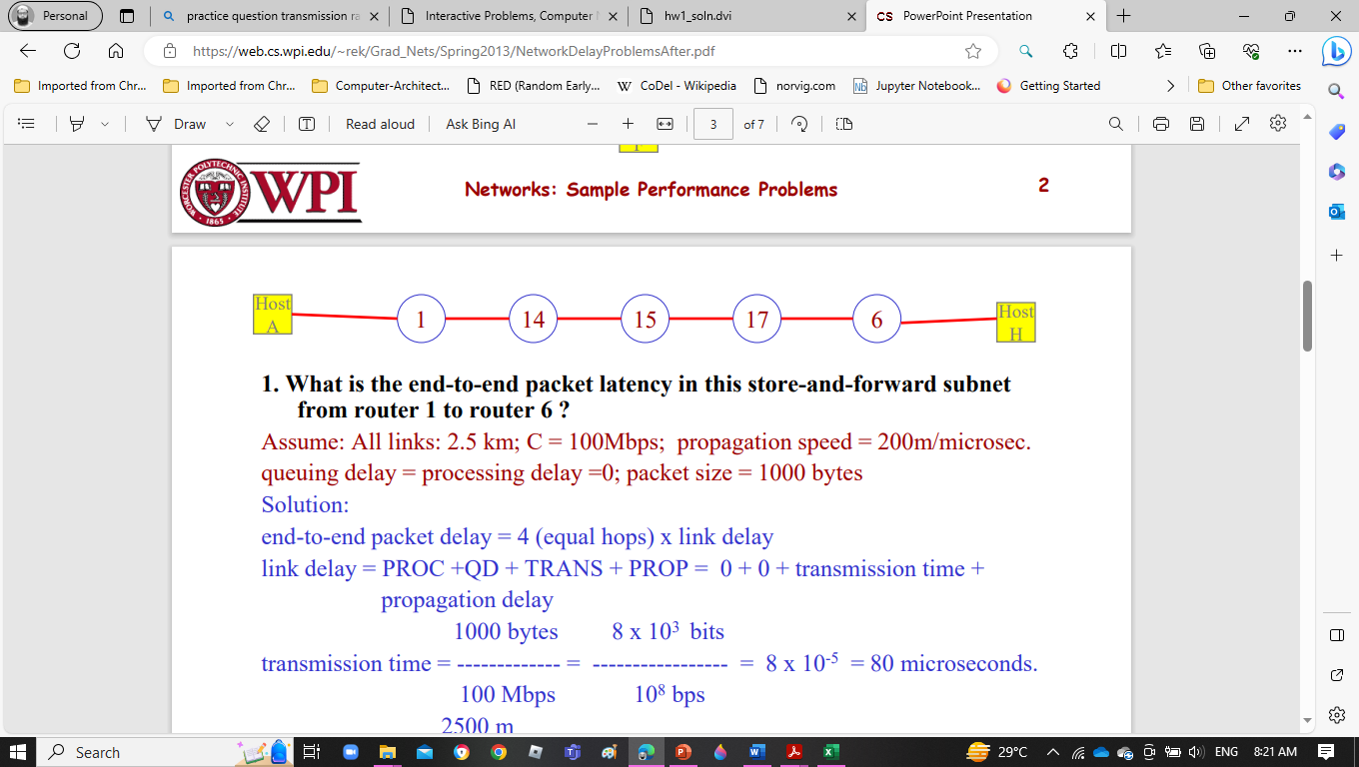

***Solution:***

***end-to-end packet delay = 4 (equal hops) x link delay***

***link delay = PROC +QD + TRANS + PROP = 0 + 0 + transmission time + propagation delay***

***1000 bytes 8 x 10^3 bits***

***transmission time = ------------- = ----------------- = 8 x {10 ^ (-5)} = 80 microseconds.***

***100 Mbps 10^8 bps***

***2500 m***

***prop delay = ---------------------- = 12.5 microseconds***

***200 m/microsec***

***link delay = 92.5 microseconds***

***end-to-end subnet delay = 4 x 92.5 = 370 microseconds***